Installation Guide

1. Open SQL Server 2014 (or higher) Management Studio.
2. 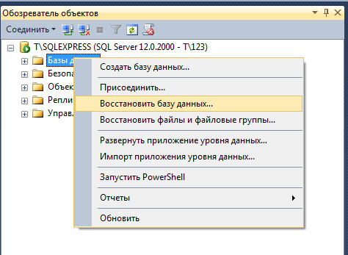Restore DataBase from Libraries.bak file.
3. Then you need to change connectionString in Library application Web.config file.

In section

<connectionStrings >

<!--CHANGE CONNECTION STRING HERE-->

<add

name="LibraryConnectionString"

connectionString="Data Source=T\SQLEXPRESS;Initial Catalog=Libraries;Integrated Security=True"

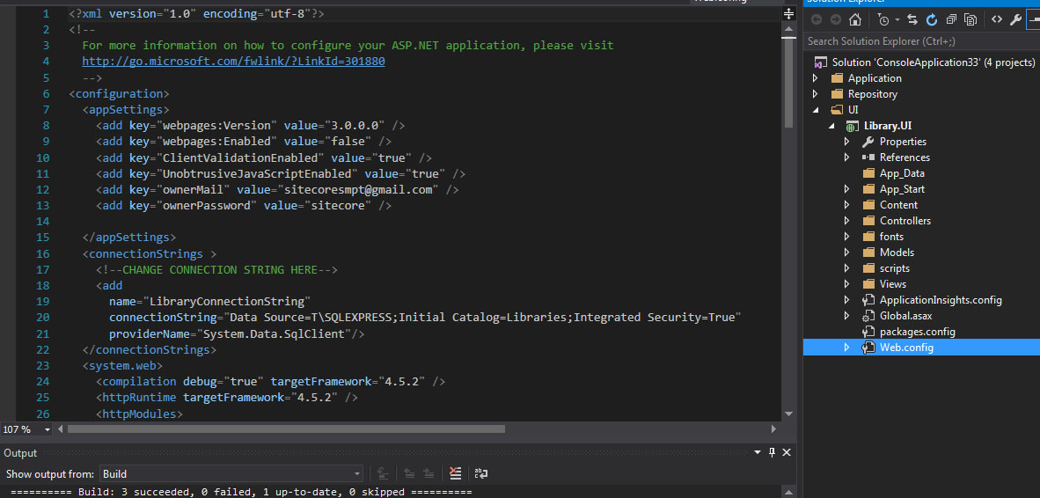 providerName="System.Data.SqlClient"/>

</connectionStrings>